October – Vision Health Announcements Grade K-5

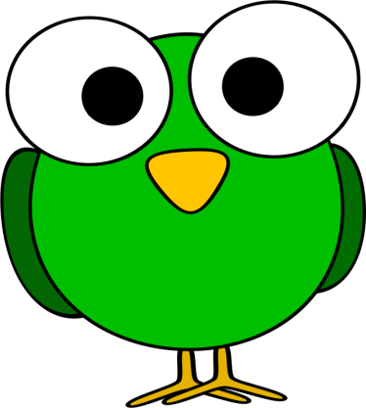

Seeing well helps you learn at school. Make sure your eyes are not tired during the day by getting a good night’s sleep. Getting at least 10 hours of sleep at night will help your eyes work best during the day.

Make sure you get your eyes checked every two years by an eye doctor. Of course, if you notice it is getting hard to see—or if you hurt your eye in any way—tell an adult so that you can get your eyes checked right away.

Did you know that eating junk food is not good for your eyes? Eating healthy foods, like fruits, nuts, and vegetables are good for your eyes.

After school, you might be watching TV, playing video games, or watching YouTube videos. Screen time is hard on your eyes. It is better for your eyes to have less than 2 hours of screen time each day.

Did you know exercise is really good for your eyes? Exercise helps blood go to your eyes. For good eye health, get at least 60 minutes of exercise a day!

The sun can hurt your eyes. When playing outside, wear sunglasses or a wide brim hat to protect your eyes from the sun and keep your vision sharp and healthy.

Your hands can carry germs which can hurt your eyes and make you sick. Make sure your hands are clean, by washing them with soap and water, before you touch your face.

